EXP-3

1. Write a shell script that takes a command line argument and reports on whether it is a directory or a file.

B)Write a shell script that takes file names as arguments and convert all of them to uppercase.

Exp A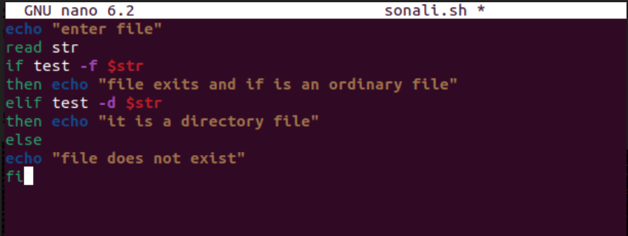

Exp B

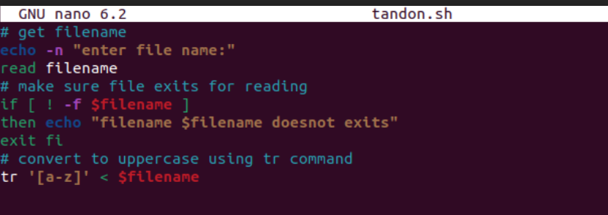

RESULT FOR EXP-3 A&B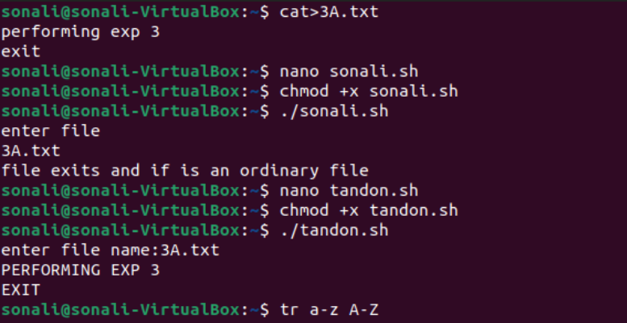

1. Write a shell script that captures the number of command line arguments and displays the arguments suppied by the user . Using grep[echo] command ,we have to search the string entered as argument one in the file name entered as argument 2.

